CREAK FAMILY HISTORY
The 19th Century

This part of the Creak family history begins with

Emily Creak (b. 1851)

Emily was born on 3 May 1851 in Great Yarmouth, Norfolk. She was the first child of John Creak and his second wife Sarah (née Gates). Emily was born in her parents’ home in Market North Road, Great Yarmouth.

Great Yarmouth is a small town on the Norfolk coast. It is situated on a narrow strip of land between the Norfolk Broads and the sea. In the 14th Century the town was fortified by the building of substantial walls around it to protect it from attacks from foreign invaders. Because of the limited space available within the walls, houses were built exceptionally close together on a grid pattern. Some of the streets, known as ‘Rows’, were as little as 27 inches (69 cm) wide. When the author Charles Dickens visited Yarmouth in 1849 he wrote: ‘A Row is a long, narrow lane or alley quite straight, or as nearly as maybe, with houses on each side, both of which you can sometimes touch at once with the finger tips of each hand, by stretching out your arms to their full extent.

‘Now and then the houses overhang, and even join above your head, converting the Row so far into a sort of tunnel or tubular passage. Many picturesque old bits of domestic architecture are to be found among the Rows. In some Rows there is little more than a blank wall for the double boundary. In others the houses retreat into tiny square courts where washing and clear starching was done.’
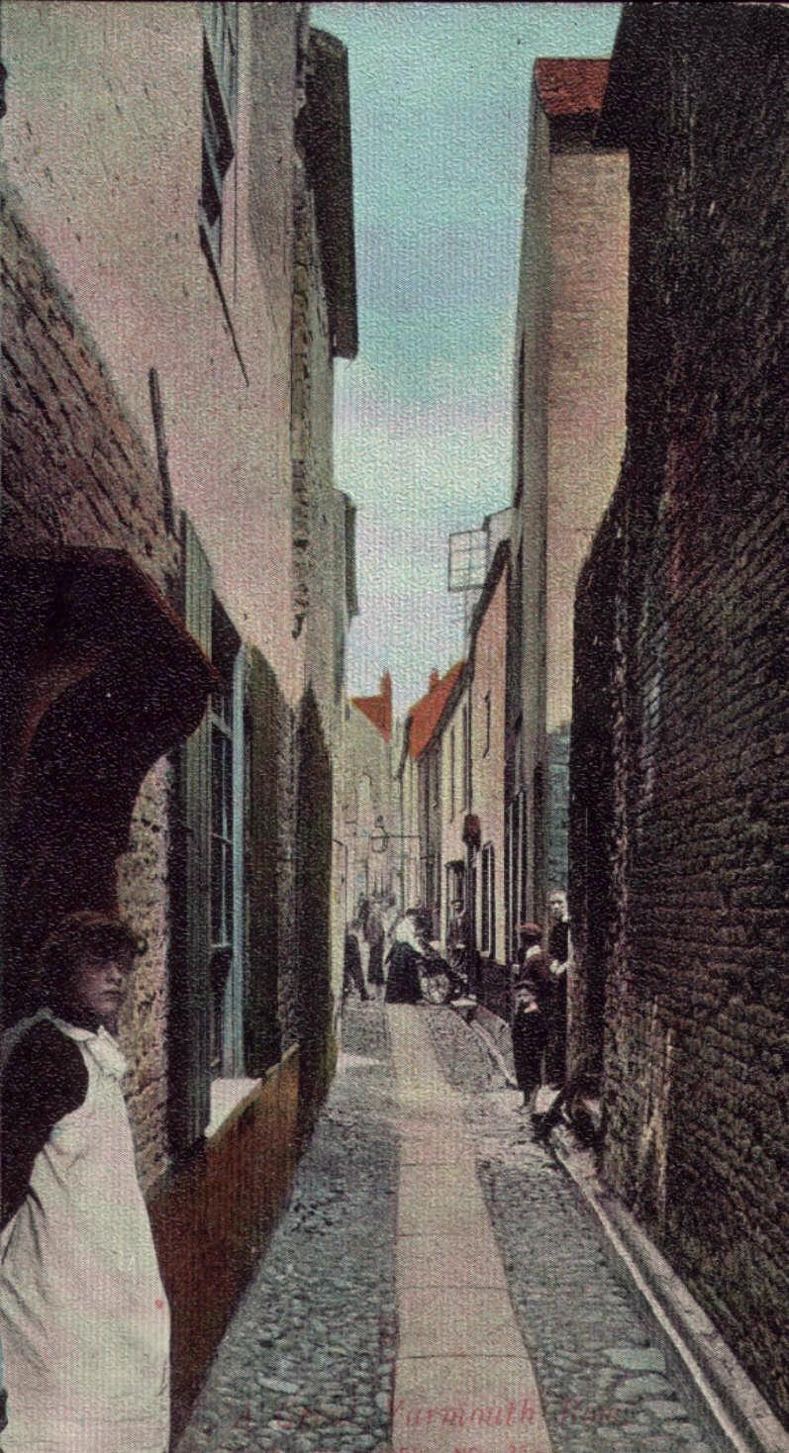
A Yarmouth Row about 1900

Originally each street had a name usually based on a significant person who lived there such as ‘Mouse the Pawnbroker’s Row’ and ‘Norman the Cabinet Maker’s Row’. Over time the names changed with some people using the old names and some the new. With 147 of these Rows it became extremely confusing so, in 1804 each was given a number. Emily’s family lived in a number of different Rows.

Emily was born two days after Queen Victoria opened the Great Exhibition of the Works of Industry of All Nations in the Crystal Palace in Hyde Park, London; the first world trade fair.

Emily’s father was John Creak and her mother Sarah (née Gates). See below. She had a brother John (b.c. 1852) and a sister Honor Matilda (b 1857). The name Honor sometimes appears as Honora. In the 1871 Census her brother John, by then aged 17, was described as a Sailmaker. The six year gap between the births of John and Honor suggests there might have been other children who perhaps died in infancy. This could be the subject of further research.

Sometime between 1852 (when John was born) and December 1857 (when Honor was born) the family moved from Great Yarmouth to London. According to a story passed down in the family, Emily and her parents sailed from Yarmouth to London on a boat, sheltering under a tarpaulin on the deck. They landed at Cherry Garden Pier on the south bank of the Thames at Bermondsey.
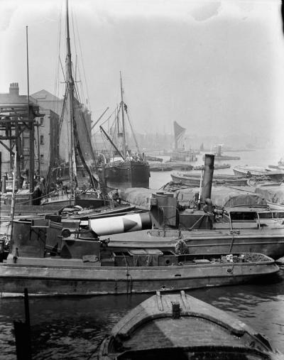
Cherry Garden Pier 1914
©National Maritime Museum, London

Cherry Garden Pier still exists and is named after the Cherry Gardens, a recreational area where Londoners often went to relax on Sundays. Samuel Pepys (1633-1703) records visiting the gardens to buy cherries for his wife.

It has not been possible to find Emily and her family in the 1861 Census indices. They were no longer living at 19 Willis Street, Bromley-by-Bow where Honor had been born four years before. Nor were they living where they lived at the time of the 1871 Census.

In the 1871 Census Emily was living with her parents and her brother and sister at 22 New Gravel Lane, Shadwell, a dockland area of London north of the Thames, only a short distance across the river from where they first landed. New Gravel Lane no longer exists and was swept away in the redevelopment of London Docklands. Stanford’s Map of London and its Suburbs, 1862, shows that New Gravel Lane ran north to south from Shadwell High Street to New Crane Wharf on the river. Part of the street was residential but a large part was taken up by dock buildings as it formed the boundary between London Docks on the west and Shadwell Basin on the east. At one point New Gravel Lane crossed a bridge over the channel which linked the Docks to Shadwell Basin. The Post Office Street Directory for 1880 shows that one of the entrances to the docks was in New Gravel Lane and that it also contained various shops, coffee rooms and, as one might expect near a dock entrance, two public houses and two ‘beer retailers’.

By then Emily was 19 years old and was working as a Dressmaker.

Later that year, on Saturday 9 December 1871, Emily married Henry Howard in Stepney Parish Church. She was aged 20. Henry Howard was a 26 year old bachelor who worked as a Rug Dresser. Both were able to sign their names on the marriage certificate. The witnesses were [?] Price and Olive Pickett. Neither appears to be a relative and were presumably friends of the bride or groom. Emily and Henry both give their ‘residence at time of marriage’ as 4 White Horse Lane [Stepney]. The 1871 Census was taken on 2 April, eight months before the marriage, but an examination of the Census for that address shows no one with their surnames living there. They could have moved in at the time of the marriage or it might have been a friend’s address, ‘an address of convenience’ entitling them to be married by Banns at St Dunstan’s, Stepney.

1871 was the year of the famous encounter in Africa between Henry Morton Stanley and the explorer Dr David Livingstone, who had been lost for three years. In Stanley’s own words: ‘I would have embraced him, only, he being an Englishman, I did not know how he would receive me. So I did what cowardice and false pride suggested was the best thing – walked deliberately to him, took off my hat, and said: ‘Dr Livingstone, I presume’.’

Emily and Henry are known to have had nine children:

John Howard bc 1873
Emily Howard bc 1875
Frank Howard bc 1877
Sarah Howard bc 1879
Florence Howard bc 1882
Ada Howard bc 1884
Ethel Howard bc 1889
Edith Howard bc 1892
Alice May Howard b 22 March 1895

By the time of the 1881 Census Henry and Emily had moved south of the Thames and were living at 80 Sumner Road, Peckham with their sons John (aged 8) and Frank (aged 4) and their daughters Emily (aged 6) and Sarah (aged 2). The three eldest children are shown as having been born in Bermondsey and Sarah in Peckham, so they must have moved south of the river by at least 1873. Henry’s occupation was now a ‘Warehouseman’. The house they lived in is shown to have been accommodating three other family units as well, making a total of 8 adults and 6 children.

At the time of the 1891 Census Henry and Emily were living at 21 Langdale Road, Peckham. Their son John, by then 18 years old, was working as a ‘Rug Finisher, Fur’. Emily (16 years old) was an ‘Ironer’, Frank (14) was a ‘Leather Dresser’. Three of the other children, Sarah (11), Florence (8) and Ada (6) were at school, where doubtless Ethel (2) would join them within two or three years. Living with them was Emily’s widowed mother Sarah Creak, aged 69, who was helping with the family income by working as a ‘Needlewoman, Shirt’. Emily and her family occupied four rooms in the house while a carpenter called Daniel McCree, aged 69, his wife and their unmarried daughter occupied the other two rooms. A number of houses in Langdale Road appear to have been in multiple occupation.

By 1901 Henry and Emily had moved to 21 Colegrove Road in Peckham, two roads to the east of Sumner Road where they were living 20 years before. This area of London was heavily bombed in WWII and has since been the subject of major redevelopment. Ariel photographs suggest that little, if any, of the Victorian housing remains today in either street. Henry’s occupation was described as ‘Warehouseman Assistant’. An elderly couple called Gould and a Boarder called Walter Wiffin lived in the same house but there is no indication that they were related.

Of Henry and Emily’s children, John (aged 28 and unmarried) was still living at home and working as a restaurant waiter. Emily and Frank do not appear in the census for 21 Colegrove Road and have presumably left home and/or married. Sarah (aged 21) is working as a ‘hand sewer’, Florence (19) is a ‘wash ironer’ and Ada (17) is a ‘carpet rug sewer’. The younger children, Ethel (12), Edith (9) and Alice (6) were still in education.

Henry’s death date has not yet been researched. Emily died on 18 August 1921 in Peckham, South London.

Emily’s father was:

John William Creak (born c. 1823)

According to later census records, John William Creak was born in Great Yarmouth about 1823.

The International Genealogical Index (IGI) does not cover baptism records for Great Yarmouth in the period around 1823. However, a search was made of the British Isles Vital Record Index which revealed a John William Creek [sic] baptised on 6 January 1823 in St Nicholas Church, Yarmouth. His parents were John and Matilda Creak. The Index showed that John and Matilda had 10 children baptised in Great Yarmouth between 1813 and 1832. John was their sixth child. Their second child (born 1815) was also called John and presumably died before 1823.

The 1841 Census index contains just six John Creaks in the whole of England, three of whom were living in Norfolk. One would expect ‘our’ John Creak to be aged about 18. Of the three Norfolk entries, one is in Burnham Market. He is shown as 15 years old and the son of a blacksmith called William Creak. We know that John’s father was also called John, so this entry can be discounted. The other two entries are for Great Yarmouth. One is for a six year old boy and so can also be discounted. The most likely, therefore, is the John Creak living at Row 42, Great Yarmouth (formerly ‘Barnby the Liquor Merchant Row’).

The census entry raises a number of interesting questions. John’s age is given as 15. However in the 1841 Census all ages over 15 were rounded down to the nearest 5 years. So, John could have been anywhere between 15 and 19 years old. His baptism record suggests he was 18. He is shown as living with some of his younger brothers and sisters - Mary Creak (aged 15, again she could have been anywhere between 15 and 19 years old; her baptism record suggests 16), William Creak (aged 10) and Robert Creak (aged 3). Robert’s baptism record (1832) suggests he would have been about 9 years old at the time of the census. Therefore, ‘3’ may be an inaccurate transcription, or the earlier Robert could have died and this is a younger child of the same name. John was working as a labourer and Mary as a ‘F.S.’, a female servant.

Their parents were not living with them at the time of the census. Their mother Matilda Creak appears elsewhere in the census at ‘North Road Market Gates’ close by, but their father, John, is not shown. It is possible that he was away from home or he could have died.

John and his siblings were living with a Mariner called Robert Churchill (aged 20; ie between 20 and 24), his wife Sarah and their two young children. The 1841 Census does not show relationships between people in a household. However, in the 1851 Census John’s mother Matilda was living with the same Churchill family and was described as Robert Churchill’s mother-in-law. We can therefore conclude that Sarah Churchill was in fact John’s sister, born Sarah Creak around 1817.

The year 1845 saw a famous disaster in Great Yarmouth. A great crowd gathered on Yarmouth Suspension Bridge to see a circus clown go down the river in a barrel pulled by geese. The bridge collapsed and about 80 people were drowned, mainly children. The tombstone of George Beloe (aged nine) in St Nicholas's churchyard depicts the bridge collapsing. It is unlikely that the Creaks were untouched by this event and may well have lost friends, even family, in the disaster.

John married Caroline Manning on 6 March 1847 in the Church of St Nicholas, Great Yarmouth. Both parties were of ‘full age’ (ie over 21 years) and neither had been married previously. John signed the register and Caroline made her mark. John’s occupation was given as ‘Mariner’. His residence at the time of the marriage was Row 35 (known formerly as Harman’s Row or Globe Row) and Caroline was living at Row 21 (formerly ‘Fill the Auctioneer’s Row’). Her father was Joseph Manning, a labourer. Witnesses were Philip Muffett, who signed, and Sarah Sadler, who made her mark.
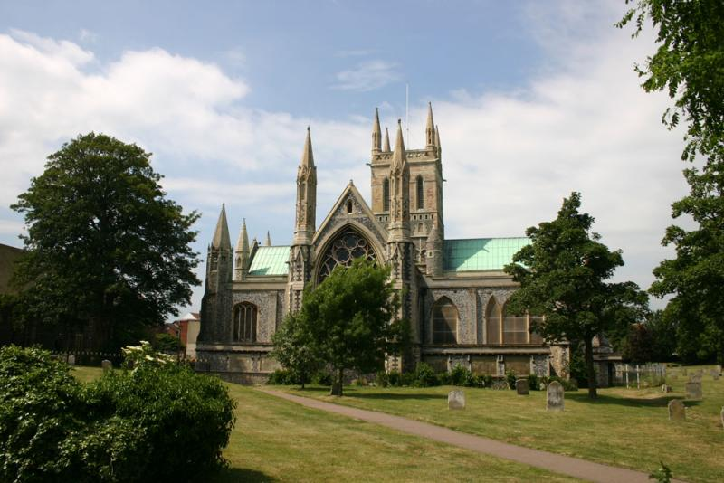
The Priory and Parish Church of St Nicholas, Great Yarmouth, is the largest parish church in England. In 1649 the great church had been divided into three parts for the use of various protestant denominations. At the same time many windows had been blocked up. Over the next two centuries the building fell into disrepair and the chancel collapsed. Restoration did not start until 1859, so when John and Caroline were married there the church would have been semi-derelict and a pale shadow of what it had once been, and indeed what it was to become again after its restoration.

1847 was the year that saw the publication of Jane Eyre by Charlotte Brontë.

Caroline died of Phthesis (Tuberculosis) just two years later, on 7 May 1849. She died in the house where they were then living in Row 102, Great Yarmouth. It is not known if there were any children of the marriage. This might be revealed by examination of the parish records.

It is interesting to note that at the time of Caroline’s death John was using the name ‘John Betts Creak’, Betts being his mother’s maiden name [see entry below].

On Tuesday 28 May 1850 John married Sarah Gates in the Parish Church of Great Yarmouth. Both were shown as of ‘full age’. She was previously unmarried. Both signed the register. Again John is described as a Mariner. She was the daughter of James Gates, a labourer. John’s residence at the time of marriage was Row 46 (formerly Nags Head Row or Sewell the Grocer’s Row) and Sarah’s was ‘Market Gates’.

John and Sarah have not yet been found in the indices of the 1851 Census. This census was taken just two months before their marriage but an examination of the census returns for their addresses when they were married (Row 46 and Market Gates) shows no one called Creak or Gates at those addresses.

John and Sarah’s first child, Emily [see entry above] was born on 3 May 1851. The birth of their second child, John James Creak, was registered in the December Quarter of 1852 in Great Yarmouth.

As noted above, sometime between 1852 and 1857 the family moved from Great Yarmouth to London. John was a mariner, and although Great Yarmouth was a flourishing port, life could be hard for sailors there. In 1851 a Sailors' strike over wages led to a riot on the Quay on 22 February. Yarmouth authorities had to call in soldiers from Norwich. Several people were injured. John’s move to London can be seen in this context and was doubtless made in the hope of a better and more rewarding life in the capital.

Another daughter, Honor Matilda was born to John and Sarah after their arrival in London, on 3 December 1857.

No trace of John and Sarah can be found in the 1861 Census indices. An examination of the census entry for 19 Willis Street, Bromley [Bromley-by-Bow], the address where they were living when Honor was born, indicates they were no longer at that address. A similar examination was made of the address where they were living at the time of the following census, but again they were not found.

By 1871 they were living with their children at 22 New Gravel Lane, Shadwell. The census records that John (aged 48) was working as a Fishmonger. Sarah was also shown as being 48 years old.

John died on 3 May 1878 in the London Hospital, Whitechapel, London, aged 55. The causes of death were Carcinoma of the Liver and ‘deposits in the lungs’. At the time of death his occupation was given as a stevedore (ie someone who loaded and unloaded ships in a dock).

In the 1881 Census Sarah, now a widow aged 57, was still living at 22 New Gravel Lane, Shadwell. Presumably she had to find employment after John’s death and she was described as a shopkeeper. Living with her were her son John (aged 28) who is shown as having been widowed and still working as a Sailmaker. There was also an unmarried Boarder in the house, Cecil Martin, aged 27.

As was noted above, by the time of the 1891 Census Sarah had moved in with her daughter Emily (Howard) and her family at 21 Langdale Road, Peckham. Her age was given as 69 and she was working as a needlewoman (shirts).

Sarah’s death has yet to be researched but she was no longer living with her daughter Emily when the census was taken in 1901.

John William Creak’s father was:

John Creak (born c.1790)

The date and location of John’s birth have not yet been investigated.

According to the International Genealogical Index he married Matilda Betts on 23 September 1810 at St Nicholas Church, Great Yarmouth.

They had 10 children, all baptised at St Nicholas:

William Creak baptised 10 May 1813
John Creak baptised 3 April 1815 (died before 1823)
Sarah Ann Creak baptised 7 January 1817
Elizabeth Creak baptised 14 December 1818
Hannah Creak baptised 15 March 1821
John William Creak baptised 6 January 1823
Mary Ann Creak baptised 10 February 1825
Harriet Creak baptised 15 May 1827 (poss. died before 1841)
William Creak baptised 31 January 1831 (born 11 December 1829)
Robert Betts Creak baptised 28 November 1832

John does not appear in the 1841 Census but his wife Matilda is shown as living at ‘North Road Market Gates’, Great Yarmouth. In the census she was described as being 50 years old (subject to the usual rounding down this could make her age 50-54), and as not having been born within the county of Norfolk. Interestingly, there is a tick against her name in the column to indicate that the person was ‘born in Scotland, Ireland, or Foreign Parts’. The 1841 Census does not record people’s marital status so it is impossible to tell if Matilda had been widowed by this date. Her occupation is described as a nurse. This may mean that she worked at the new Yarmouth Hospital which had been built in 1839, just two years before the census.

The fact that Matilda was working even though she had small children suggests that her husband John might have already died. However, the marriage certificates of their son John (1847 and 1850) do not indicate that his father was deceased, as would usually have been the case. This could be the subject of further research in the parish records.

It is interesting to speculate on whether John (if still alive) and Matilda saw Charles Dickens during his extended stay in Great Yarmouth in 1849. Much of his novel David Copperfield is set in Yarmouth.

John had certainly died by 1851 as his wife Matilda is described as a widow in the census. Her age was given as 66 and she was shown as not having an occupation any longer. She was living with the Churchill family which, as noted above, was the family of her daughter Sarah. (Strangely, Sarah is called ‘Sussannah’ [sic] in this census. Her full name was Sarah Ann, and Sussannah is probably an inaccurate transcription by the census enumerator.)

Despite the suggestion in the 1841 census that Matilda was born in ‘Scotland, Ireland or Foreign Parts’, she is shown as having been born at Metfield in Suffolk, about 30 miles from Great Yarmouth. This could be the subject of further investigation in the parish records.

It has not been possible to find Matilda in the 1861 Census, nor the Churchill family with whom she had been living.

She was presumably the Matilda Creak whose death was recorded, aged 82, in the September Quarter of 1868 in Yarmouth.

NOTES

This part of the Creak family history has been particularly difficult to research. While it is not unknown for people to be absent from Census records, or at least from the indices, the Creaks are notable for the large number of times they are absent. This is especially surprising as unusual surnames, such as Creak, are usually the easiest to trace. One can only guess at the reason. They might have had an aversion to being recorded, or they might have lived in highly populated areas where they could have been missed by census enumerators. Alternatively, they may have been indexed incorrectly. Certainly some of those references that have been found were discovered only after a good degree of detective work.
Birth certificate June Quarter 1851, Vol 13, page 429.
Census 1871, RG10/544/44
Census 1871, RG10/544/44
Marriage Certificate in possession of the family.
Census 1881 and 1901
Census 1881, RG11/697/13
Census 1891, RG12/480/101
Census 1901, RG13/509/159
Her date of death comes from the list of obituaries in the St Andrew’s Church, Peckham, Parish Magazine for September 1921 (copy in possession of the family).
Caroline Creak. Death registered June Quarter 1849, Vol 13, page 287.
John James Creak. Dec Quarter 1852, Vol 4b, page 18.
Honor Matilda Creak. March Quarter 1858, Vol c, page 601.
British Isles Vital Record Index.
1851 Census. HO107/1806/70
Death certificate, September Quarter, Vol 4b, page 3.

